Cloud Security: Pro-Quantum
Harshit Saha¹[0009-0001-9355-3442] and Dr. Dinesh Kumar Saini²[0000-0002-5140-1731]
¹ School of Computing and Intelligent Systems, Manipal University Jaipur, Jaipur, India
² School of Computing and Intelligent Systems, Manipal University Jaipur, Jaipur, India
dineshkumar.saini@jaipur.manipal.edu
Abstract. The paper reveals the emerging prospect of data security in cloud computing, highlighting the emerging threats posed by quantum computing algorithms to traditional encryption protocols. Quantum resistant methods are required to protect sensitive data from Quantum adversaries. Current encryption protocols face susceptibility from quantum algorithms such as Shor’s and Grover’s algorithms because they can break these cryptographic methods. SOAR is the proposed solution which has security tools integrated in it to direct cloud security operations and locate threats in real-time. SOAR uses AES-512 for symmetric encryption and RSA-4096 for asymmetric encryption which ensures data confidentiality both when at rest as well as in transit. TLS 1.3 is used for securing network communications using AES-512 and RSA-4096 for encryption. The architecture of AES-512 involved various transformations in steps like byte substitution, shift row, mix column, and add round key and on the other hand RSA-4096 involved key generation, key distribution, encryption and decryption using large prime numbers. The paper indicates the immediate need for developing and starting the use of quantum-resistant cryptographic algorithms to reduce the threat of quantum computing.
Keywords: Cloud Security Protocols, SOAR, AES-512, RSA-4096.
- Introduction
The advancing landscape of data security in cloud computing, highlighting the increasing risks posed by quantum computing to traditional encryption protocols is a critical concern for organizations worldwide. The dependence on cloud services for storage of data and its processing is growing exponentially. With the imminent threat of quantum adversaries, the need for quantum-resistant encryption methods has become paramount. Quantum computers have the potential to render the current cryptographic protocols useless. By embracing quantum-resistant encryption techniques and harnessing the power of quantum mechanics, organizations can navigate the challenges of the post-quantum era and safeguard their sensitive data effectively.
Quantum attacks may pose a risk to asymmetric and symmetric cryptography encryption methods because quantum computers could be capable of performing calculations that can decrypt them. In this paper we will discuss the current schemes of security encryption protocols and the way to solve the quantum computing security threats to cloud using SOAR.
  - Existing Cloud Encryption Protocol

In today’s world, data is considered as the most important resource and is flowing through the internet and all of it is stored on cloud. There have been many enhancements in the current encryption techniques which is hard to break from attackers. [1], [2]
Diffie-Helman key exchange protocol: For every calculation in this algorithm, the modulus is a prime number. An attacker will find it more difficult to brute force the shared secret the larger the number. True Diffie-Helman exchanges operate on enormous bit counts that correspond to prime integer sizes. This corresponds exactly to the full shared secret's key space. Any Diffie-Helman (DH) group with less than 2048 bits is not regarded as secure.
AES (Advanced Encryption Standard): It is a symmetric block cipher algorithm with a block/chunk size of 128 bits. Grover's algorithm can effectively halve the effective length of the key of AES, meaning that a 128-bit AES key would be able to provide the same level of security against a quantum computer as a 64-bit key would against a conventional computer. Despite AES's resistance to attacks from conventional computers, Grover's algorithm has the potential to break it.
RSA: RSA is a cryptography algorithm which is asymmetric. The working principal of RSA is that it is difficult to factorize a large integer.[3], [4] Two numbers together make the primary key, where one number is a multiple of two large prime numbers. If someone factorizes the large number, the private key is compromised. The encryption strength is based on the key size and if the key size is doubled or tripled, the strength of encryption is increased exponentially. Through Shor's algorithm, one can efficiently factor large numbers, making RSA less secure.
- Issues and Challenges
  - Potential Attacks and Security Risks
Given that quantum computers have the ability to beat widely used cryptographic methods which are the foundation of modern cybersecurity, quantum computing threats produce a future cybersecurity risk.[5]
Quantum Power and Speed. As compared to classical computers, quantum computers are able to execute some computations a lot more faster. This could result in established cryptographic techniques being more vulnerable to quantum attacks, such RSA and ECC (Elliptic Curve Cryptography).
Shor’s Algorithm. This algorithm can factor big numbers much more quickly than traditional algorithms. Large integers can be factorised in polynomial time, which allows it to break RSA encryption—which normally requires 128,192, or 256-bit keys—much more quickly and effectively in a matter of few seconds. It would make encryption systems in use today more susceptible to attacks from potent quantum computers.
Breaking Symmetric Key Algorithms. AES (Advanced Encryption Standard) and other symmetric key algorithms could be weakened by quantum computers. Grover's algorithm, is another quantum algorithm that can search through unarranged databases more quickly than earlier algorithms, reducing the symmetric ciphers' effective length by half. Research into quantum resistant cryptography algorithms is being conducted in order to be ready for the time when quantum computers and algorithms are feasible and secure communication is attainable.
- Solutions
In today’s world all the data is constantly being transmitted or stored in cloud. SOAR could be used to automatically detect threats and respond to them in real-time, reducing the risk of unauthorized access to cloud data. It integrates security tool and processes, enabling structured and practical management of security operations of cloud. It can recognize suspicious activities that may reveal compromised accounts or insider threats. The AES-512 is used in SOAR for symmetric encryption and RSA-4096 for asymmetric encryption of data stored in cloud, data remains unreadable without the decryption key. Data in cloud needs to be secured from unauthorized access. AES-12 is used in securing HTTPS connections between user’s browser and cloud service using TLS with AES-512 as the encryption cipher. RSA-4096 is important to cloud security, distinctly for secure key exchange, digital signatures and establishing secure communication channels.[6], [7]
  - SOAR (Security Orchestration, Automation, and Response)
It holds a host of encryption mechanisms and secure protocols to ensure the confidentiality, integrity, and accessibility of data at rest, in transit and in use. It uses both symmetric and asymmetric encryption mechanisms to meet various needs. It uses AES-512 for symmetric encryption and RSA 4096-bit keys for asymmetric encryption and secure protocols like TLS 1.3 for network security. For password protection, hashing algorithms like bcrypt(up to version 39) and PBKDF2WithHmacSHA512 for v39+ are being used.

  - TLS 1.3
TLS(SSL) protocol uses a handshake mechanism which requires one round trip instead of two, reducing the time by a few milliseconds. When the client had connected to website before, the latest TLS handshake will have zero trips. The TLS handshake will open a secure connection and exchange the public key. TLS also generates session keys which encrypt and decrypt all communications after the handshake. TLS provides authentication on the server side and also ensures that the data has not been tampered with or altered as a MAC is included with every transmission.

  - AES-512
The AES 512 contains an input block of 512 bit and key of 512 bits each which are arranged in bytes. Its procedure consists of 10 rounds and the derived cipher text is also of 512 bits. The proposed algorithm of AES 512 bits has four distinct byte-based transformation. Byte substitution is the first transformation which replaces the value of 512 bit , which are attained by using parallel s-boxes. The shifting of rows being second transformation in which the rows of the output from previous step by an offset equal to the row numbered. The mixing of columns being the third step, where each column of the output from previous transformation is multiplied by a different value . The final transformation is adding a round key to the result of this round.[8], [9]
  - RSA-4096
It is an asymmetric encryption algorithm that uses keys - a public key which is used for encryption and a private key for decryption. The 4096 refers to the key size, the larger the key means more security but also more computational overhead.
- AES-512 Architecture
  - Byte Substitution.
The 512 bits of input plaintext block is organized in array of 64 bytes and are replaced by values attained from substitution boxes or s-boxes. It is done to procure more security w.r.t diffusion-confusion Shannon’s principles for cryptographic algorithm design.
  - Shift Row.
In shift row, the rows of the resulting matrix from the byte substitution are shifted in a process called Shift row Transformation. The bytes in each row in the input data matrix will be rotated left. The number of left rotations is not the same in every row, and it is determined by row number. An operation must be applied on the columns of the data matrix after the rows of input data are rotated left by distinct offsets. The Mix Column operation is the product of the columns in the data matrix with a fixed polynomial of a(x).
  - Add Round Key:
To make the connection between the key and the ciphertext more complex, hard to understand and to satisfy the confusion principle, the Add Round Key operation is executed. This addition step takes the resulting data matrix from the preceding step and executes on it a bitwise XOR operation with the sub key of that specific round.

  - Key expansion and rounds:
The 512-bit input key of the new AES-512 algorithm is used to create ten sub-keys for all of the ten AES rounds. The operation will be bitwise XORing with the round key enlarged using the key expansion process. The output received after the 10th round will be the 512-bit encrypted message.
  - FLOWCHART for AES 512 bits
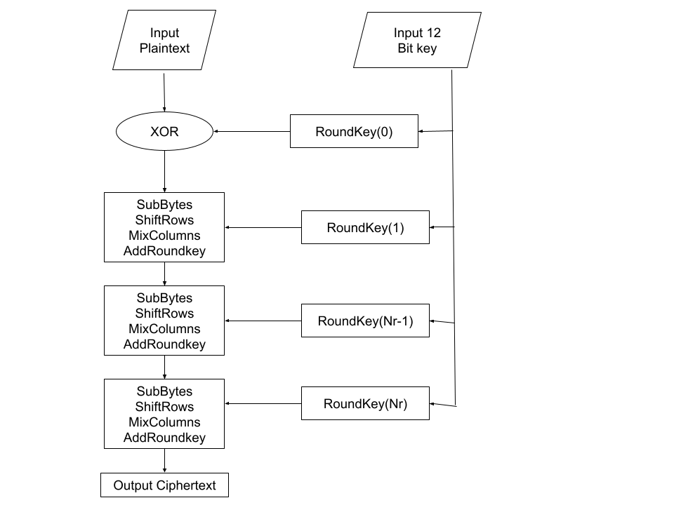
Fig. 1. AES-512 Encryption process
  - How Shor’s Algorithm endangers AES:
Shor’s algorithm uses the principles of quantum computing to factor large integers very fast. But Shor’s algorithm doesn’t directly apply to AES as it does not rely on integer factorization or discrete logarithms for its security. AES security is based on the practical infeasibility of performing brute-force key search and the complexity of performing cryptanalysis against the cipher.
- RSA-4096 Architecture:
  - Key generation:
Choose two distinct large prime numbers and multiply them together. The product generated will be the public key with an public exponent which is available to everyone and a private key with a private exponent which is available to the receiver to whom message has to be sent.
- Select two distinct large prime numbers, p and q. For RSA-4096, these primes have to be very large, at least 2048 bits each.
- Compute n: n is product of the two prime numbers p and q and n is parts of both the public and private keys.
- Compute Ф(n), the totient function.
Ф(n)=(p-1) *(q-1) (1)
- Select an integer e which will be public exponent that satisfies 1<e< Ф(n) and gcd(e, Ф(n))=1.
- Calculate d which will be private exponent as the modular multiplicative inverse of e modulo
Ф(n): d=e⁻¹mod Ф(n) (2)
- The public key is (n,e) and the private key is (n,d). The values of p, q, and Ф(n) should be kept secret.

  - Key Distribution:
The key distribution process in RSA is done through Public Key Infrastructure (PKI). The public key is distributed freely and available to anyone who wants to send a secure message to the owner of that key. It is shared through any communication channel without worrying about its security because it cannot be attacked. If any attacker receives the public key they cannot derive the private key because of the computational difficulty of factoring large prime numbers, which is the security point of RSA.
  - Encryption:
When someone sends an encrypted message, they use the recipient’s public key to change the original message (plaintext) into a mixed-up message (ciphertext). The encryption is done using a mathematical operation which is used for conversion which in turn involves public key and plaintext. When a plaintext message m and public key(n,e), then the ciphertext c is calculated by ,(Fig 2.)
c= m^e mod n. (3)
  - Decryption:
The ciphertext when received, the recipient transforms the ciphertext back into the original plaintext using the private key. It is done using a mathematical operation which involves the private key and the ciphertext. When a ciphertext c and the private key (n,d), the plaintext m is received by decrypting ciphertext by calculating(Fig 3.)
m=c^d mod n. (4)
  - Certificate Authorities (CAs):
To ensure the authenticity of the public key in cloud, there is a third party called CA. The CA authenticates the identity of the entity, then issues a digital certificate which binds the entity’s identity with its public key. To communicate securely with that entity, they check the digital certificate to check whether the public key belongs to the entity it is representing.[10]
  - Flowchart of encryption and decryption of RSA
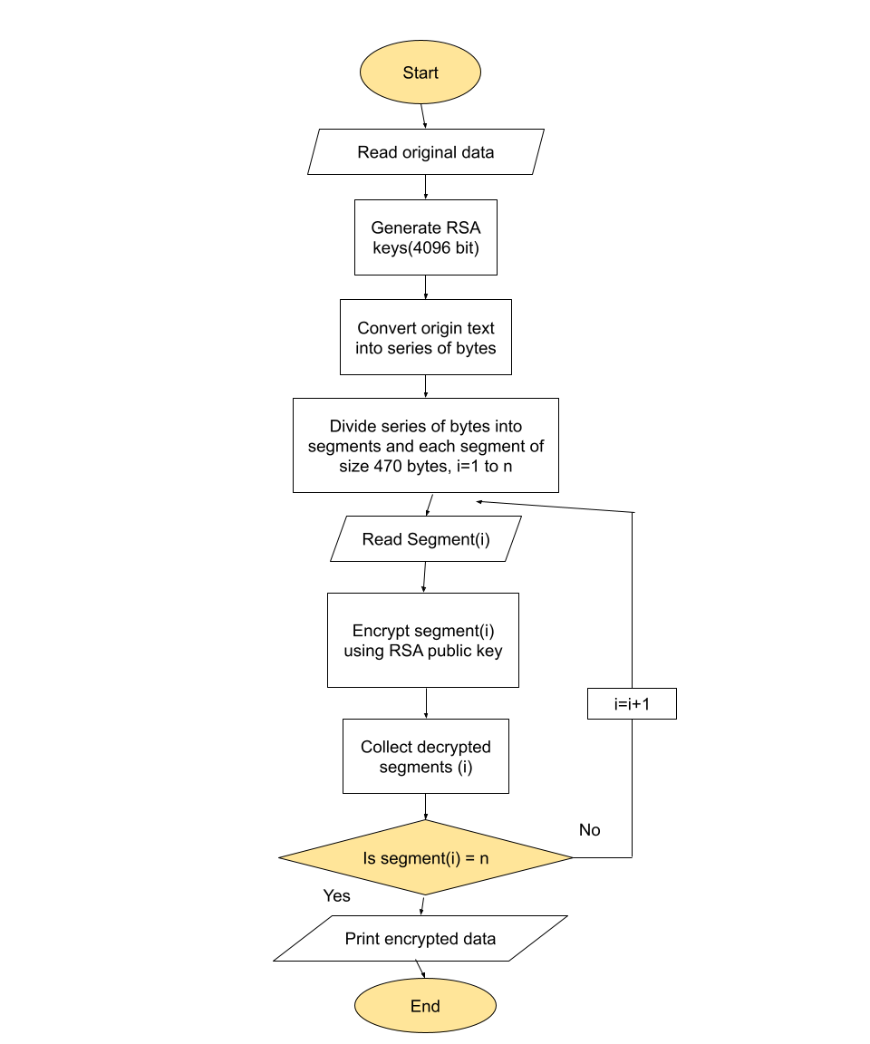
Fig. 2. RSA-4096 Encryption process
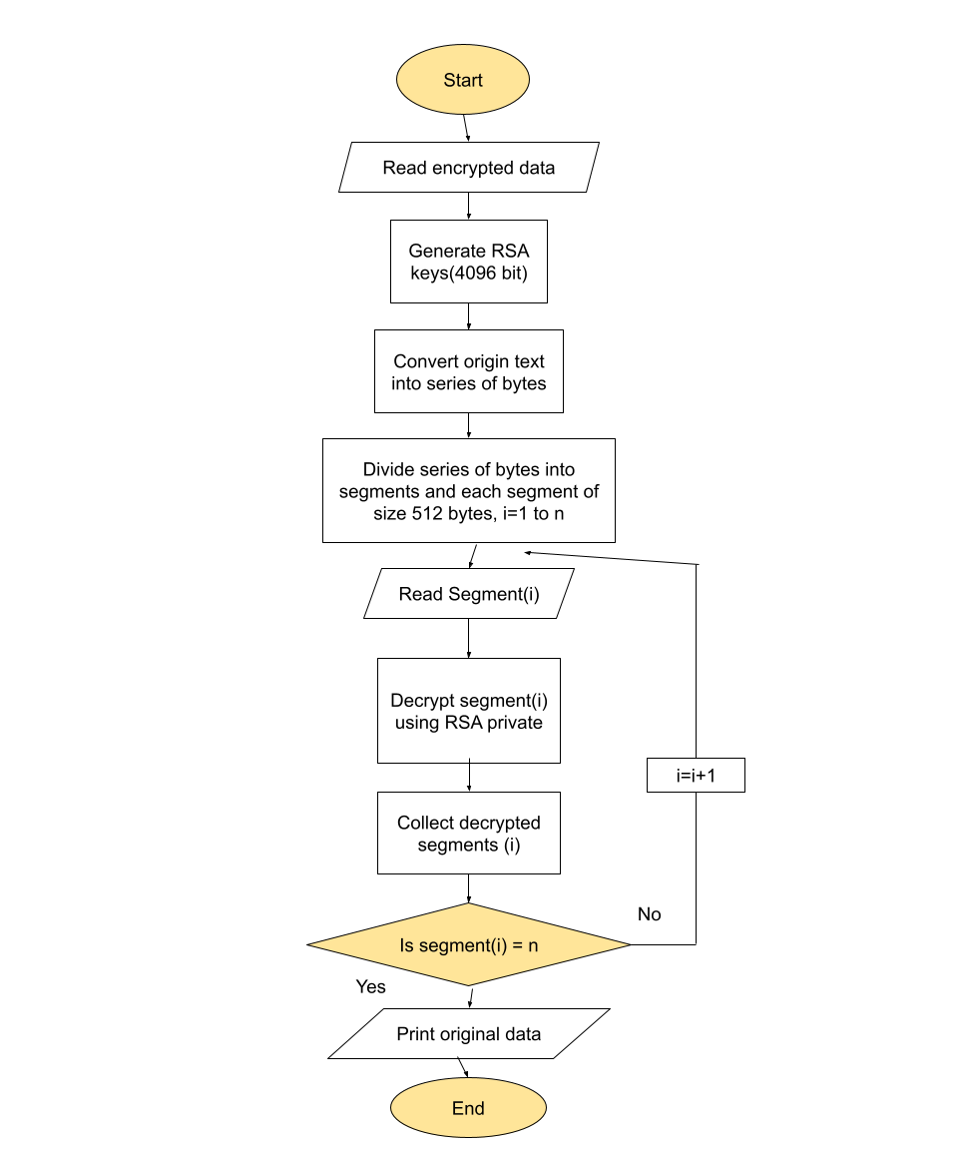
Fig. 3. , RSA-4096 Decryption process
- Future Scope
SOAR is going to grow exponentially in the next decades, there are going to be various aspects in which there will be places for growth for SOAR. Increased integration with systems like extended detection and response (XDR) , and continuous focus on security automation for more efficient and scalable operations . SOAR tools will be modified to detect and respond to new attack algorithms and patterns, like exploiting third-party applications hosted on cloud and everyday vulnerabilities.
- Conclusions
In this paper, we examined how the emergence of quantum computing presents serious difficulties for the traditional cryptographic protocols that support contemporary security systems, particularly in the context of cloud computing security. Encryption techniques that have long protected sensitive data from quantum attacks are growing more vulnerable as quantum computers gain in strength. This paper investigates the weaknesses of current cryptographic protocols against threats from quantum computing, such as Diffie-Hellman, AES, RSA. It also emphasizes the necessity for quantum-resistant cryptography solutions and the potential effects of quantum assaults on symmetric and asymmetric encryption techniques.
This paper recommends the usage of SOAR (Security Orchestration, Automation, and Response) which is a potential quantum-resistant encryption technique, as a solution to these issues. It is the mix of well-secured protocols such as AES-512 for symmetric encryption and RSA 4096-bit keys for asymmetric encryption and secure protocols like TLS 1.3 for network security. It offers a feasible way to reduce the threats posed by quantum attackers. It involves executing policies that approve the use of quantum-resistant encryption and continuously examining cloud environments for complying with these policies. SOAR can automate the change to quantum-resistant network security protocols such as TLS 1.3 with AES-512 and RSA-4096 as the quantum-resistant ciphers which in turn ensures that the communication between clients and cloud services remain secure against quantum attacks.[11]
The paper also reveals that Shor's method can factor huge integers faster than traditional algorithms. In view of cutting-edge quantum technology, this article emphasizes how strongly businesses must endorse quantum-resistant encryption techniques to preserve data security. It does this by providing a brief description of how AES-512 and RSA-4096 algorithm are implemented along with their encryption and decryption techniques.

References
[1] D. Bacon and W. Van Dam, “Recent progress in quantum algorithms,” Commun. ACM, vol. 53, no. 2, pp. 84–93, Feb. 2010, doi: 10.1145/1646353.1646375.
[2] T. D. Ladd, F. Jelezko, R. Laflamme, Y. Nakamura, C. Monroe, and J. L. O’Brien, “Quantum computing,” Nature, vol. 464, no. 7285, pp. 45–53, 2010, doi: 10.1038/nature08812.
[3] S. K. Leyton and T. J. Osborne, “A quantum algorithm to solve nonlinear differential equations,” Dec. 2008, Accessed: Apr. 30, 2024. [Online]. Available: http://arxiv.org/abs/0812.4423
[4] R. L. Rivest, A. Shamir, and L. Adleman, “A method for obtaining digital signatures and public-key cryptosystems,” Commun. ACM, vol. 21, no. 2, pp. 120–126, Feb. 1978, doi: 10.1145/359340.359342.
[5] “(PDF) The Future of Quantum Computing and its Potential Applications.” Accessed: Apr. 30, 2024. [Online]. Available: https://www.researchgate.net/publication/375794385_The_Future_of_Quantum_Computing_and_its_Potential_Applications
[6] A. Wicaksana, Anthony, and A. W. Wicaksono, “Web-app realization of Shor’s quantum factoring algorithm and Grover’s quantum search algorithm,” Telkomnika (Telecommunication Computing Electronics and Control), vol. 18, no. 3, pp. 1319–1330, 2020, doi: 10.12928/TELKOMNIKA.V18I3.14755.
[7] “Qiskit | IBM Quantum Computing.” Accessed: Apr. 29, 2024. [Online]. Available: https://www.ibm.com/quantum/qiskit
[8] A. Montanaro, “Quantum algorithms: An overview,” npj Quantum Inf, vol. 2, no. 1, Nov. 2016, doi: 10.1038/NPJQI.2015.23.
[9] C. G. Almudever, L. Lao, R. Wille, and G. G. Guerreschi, “Realizing Quantum Algorithms on Real Quantum Computing Devices,” Proceedings of the 2020 Design, Automation and Test in Europe Conference and Exhibition, DATE 2020, pp. 864–872, Mar. 2020, doi: 10.23919/DATE48585.2020.9116240.
[10] S. G. Chaloop and M. Z. Abdullah, “ENHANCING HYBRID SECURITY APPROACH USING AES AND RSA ALGORITHMS,” Journal of Engineering and Sustainable Development, vol. 25, no. 4, pp. 58–66, Jul. 2021, doi: 10.31272/JEASD.25.4.6.
[11] “A General Implementation of Shor’s Algorithm | by Chaitanya Ravuri | MIT 6.s089 — Intro to Quantum Computing | Medium.” Accessed: Apr. 29, 2024. [Online]. Available: https://medium.com/mit-6-s089-intro-to-quantum-computing/a-general-implementation-of-shors-algorithm-da1595694430

